# Lab Task1:

1. Are there any other jealous people in KB5?

jealous(X,Y).

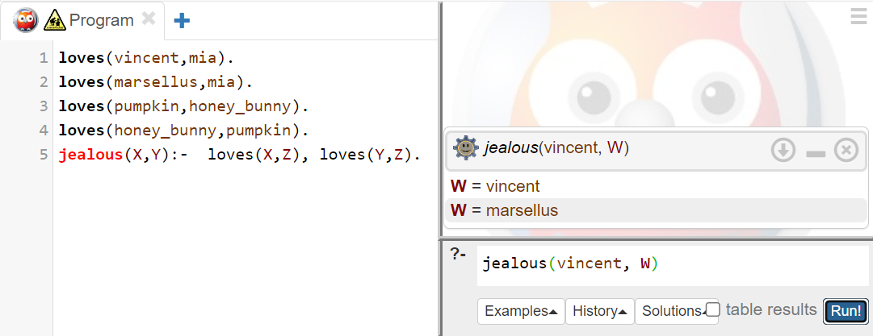

1. Suppose we wanted Prolog to tell us about all the jealous people: what query would we pose? Do any of the answers surprise you? Do any seem silly?

marcellous is jealous of marcellous.

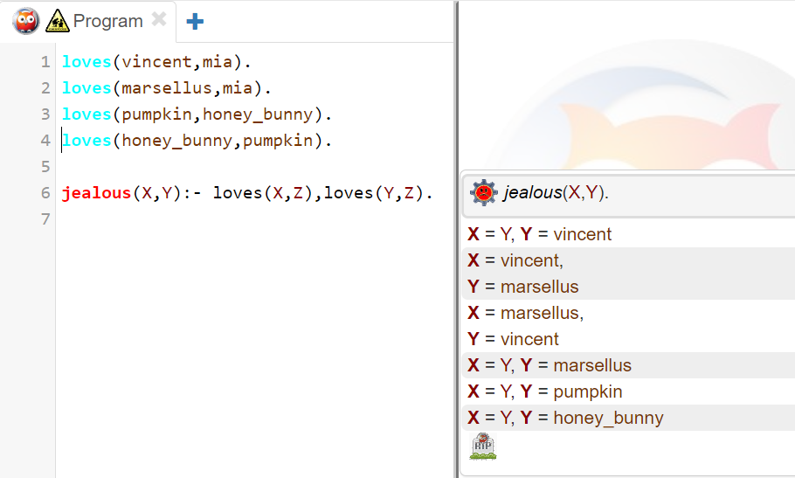

1. Which of the following sequences of characters are atoms, which are variables, and which are neither?
   1. vINCENT
   2. Footmassage
   3. variable23
   4. Variable2000
   5. big_kahuna_burger
   6. ’big kahuna burger’
   7. big kahuna burger
   8. ’Jules’
   9. _Jules
   10. ’_Jules’

**vINCENT**-**atom**-starts with a lower-case letter.

**Footmassage**-**variable**-starts with a capital letter.

**variable23**-**atom**-starts with a lower-case letter.

**Variable2000**-**variable**-start with capital letter.

**big_kahuna_burger**-**atom**-start with lower case

**‘big kahuna burger’**-**atom**-single quote

**big kahuna burger**-**neither** - looks like a sentence

**‘Jules’**-**atom**-single quote

**_Jules** -**variable** -variable start with _ or Uppercase

**‘_Jules’** -**atom** -single quote

1. Which of the following sequences of characters are atoms, which are variables, which are complex terms, and which are not terms at all? Give the functor and arity of each complex term.
2. Loves(Vincent,mia)
3. ‘loves(Vincent,mia)’
4. Butch(boxer)
5. boxer(Butch)
6. and(big(burger), kahuna(burger))
7. and(big(X), kahuna(X))
8. _and(big(X), kahuna(X))
9. (Butch kills Vincent)
10. kills(Butch Vincent)
11. kills(Butch,Vincent)

a. **loves(Vincent,mia)**- **complex term**, loves/2 (arity-2)

b. ’loves(Vincent,mia)’- **atom** – single quote

c. Butch(boxer)- not an atom, variable, or complex term

d. **boxer(Butch)** - **complex term**, boxer/1

e. and(big(burger), kahuna(burger)) - **complex term** and/2

f. and(big(X), kahuna(X))-**complex term** and/2

g. _and(big(X), kahuna(X))-not an atom,variable,or complex term

h. (Butch kills Vincent)- not an atom, variable, or complex term

i. kills(Butch Vincent)- not an atom, variable, or complex term

j. kills(Butch,Vincent) - **complex term** and kills/2

1. How many facts, rules, clauses, and predicates are there in the following knowledge base? What are the heads of the rules, and what are the goals they contain?

woman(vincent). woman(mia). man(jules).

person(X):- man(X); woman(X).

loves(X,Y):- father(X,Y).

father(Y,Z):- man(Y), son(Z,Y).

father(Y,Z):- man(Y), daughter(Z,Y).

**3 facts:**

woman(vincent). woman(mia). man(jules).

**4 rules:**

person(X):- man(X); woman(X).

loves(X,Y):- father(X,Y).

father(Y,Z):- man(Y), son(Z,Y).

father(Y,Z):- man(Y), daughter(Z,Y).

totals 7 clauses.

**Predicates**: woman/1, man/1, person/1, loves/2, father/2,son/2,daughter/2.

**Head**: left-hand sides of a rule:

person(X), loves (X, Y), and father (Y, Z).

**Goals**: right-hand sides of a rule and are man(X), woman(X), Father (X, Y), man(Y), son(Z, Y), and daughter(Z,Y).

1. Represent the following in Prolog:
   1. Butch is a killer.
   2. Mia and Marsellus are married.
   3. Zed is dead.
   4. Marsellus kills everyone who gives Mia a foot massage.
   5. Mia loves everyone who is a good dancer.
   6. Jules eats anything that is nutritious or tasty.
2. killer(butch).
3. married(marsellus,mia).
4. dead(zed).
5. kills(X,marsellus) :-footmassage(X,mia).
6. loves(mia,X) :-good_dancer(X).
7. eats(jules,X) :-nutritious(X);tasty(X).
8. Suppose we are working with the following knowledge base:

wizard(ron). hasWand(harry). quidditchPlayer(harry).

wizard(X):- hasBroom(X), hasWand(X). hasBroom(X):- quidditchPlayer(X).

How does Prolog respond to the following queries?

* 1. wizard(ron).
  2. witch(ron).
  3. wizard(hermione).
  4. witch(hermione).
  5. wizard(harry).
  6. wizard(Y).
  7. witch(Y).

wizard(ron). - True

witch(ron). - Undefined procedure witch/1

wizard(hermione).- False

witch(hermione). -Undefined procedure witch/1

wizard(harry). - True

wizard(Y). - Y = ron ; Y = harry

witch(Y). - Undefined procedure witch/1